**NAME**

**REG NUMBER**

**TOPIC:** What factors affect chief executive officer salaries?

**ABSTRACT**

Workforce dynamics come in many forms. A typical company deals with so many factors, some of which have endless needs form day to day. Within an organization structure there are different types of functional departments such as, the Human Resource, Information technology, Supply chain and procurement, Sales and Marketing, Customer service and Front office. At the top of all these are the management staff.

Whereas the management of most of these organizations differ from one company to the other, ideally most of them follow at least one method of leadership style. The most common being the top down approach of management where the management at the top is headed by the founder, then board of directors and finally other directors and line managers to employees who are at the bottom lower domain. Further, different companies have different methods and techniques of awarding and paying their top leadership.

It’s a common belief that senior employees who are at the top of leadership and management are the most paid and take home high salaries and incomes at the end of every month, get more bonuses and are the most gifted every financial year. Well, this study sought out to identify if some of these issues could be true or not, took down a case by case study review and then articulated the findings and conclusions of these studies.

**Introduction:**

While looking at both the private and public sector, one can almost argue that the top management is and CEOs of certain companies are the most valued. Partially, this is true, but also untrue to a greater extent and some of the CEOs leading some of the successful companies are the unhappy ones, D’Ambrosio et al (2020). Psychologically, money has been ranked as not being the best item in making people happy. It’s also true that one can have high salaries yet they are still unhappy.

Companies will also only pay higher salaries if they company is doing well, and that is why a bigger chunk of the stress falls on the back of the Chief executive officers and top tier management. If the company fails, they are also considered to have failed and have to go home. According to Singh et al (2019), In lieu of this, most companies whether in the private sector or public sector are considering a number of factors to cushion their top management from falling into the traps of poor performance and ensure that they can only give their best since they are the eyes of the company. They relay and communicate the vision and roadmap missions of the company on behalf of the shareholders. Forming the part of this study and research, one of the questions that the researcher aims to answer is how they aim to achieve this.

**Background study and problem statement.**

Money as a tool of economic production together with labor have been put on test in so many cases to help determine how and why successful companies meet their target objectives and goals. The very first item that rings into the job seekers mind whenever they want to jump from one company to another is always the financial remuneration and package.

Whereas most companies do not put this as part of their checklist, some of them consider items like healthcare and insurance for the top CEOS. So one would ask, what makes bright the difference in salaries and remuneration of top management in different companies across the globe? To answer, let’s discuss some of the factors that makes different employees earn varyingly from other employees in other companies;

Current market share of a company is a contributing factor. A company that has a greater monopoly of the market share makes more profit and is able to pay its employees well. In turn, good financial performance of a company is attributed to the fact the chief executive officers made good decissions that drove the business into profits.

Organizational reputation. Some companies their employees well because they are known for it. The United Nations for example has been known to pay its staff at international scope and levels, the pay grade and structure beats what most of other employees in developing nation earn.

Age of the company in business. It has been known for long that employees who are part of startup companies will earn slightly different from their counterparts who have been in organizations that have existed for quite a while.

Type of organization. It may be true that government staff are well funded and have a consistent rate of pay regardless of the department. This is untrue for most of the private sector companies that may only pay lower than the expected since private companies are prone to a lot of factors in the economy that can affect their performance.

This study is significant in evaluating the causal factors and variations in salaries between CEOs of companies and the factors affecting such salaries.

**Project Aims and objectives**

The researcher seeks to establish the following aims and objectives in this study:

1. To establish the relationship between employee job satisfaction and amount of salary
2. To establish the relationship between CEO salaries and the tape of companies they work in
3. To establish the relationship between company type and the CEO salaries
4. To establish the relationship between the company location and their CEO salaries

**Literature review**

According to Chaudhry et al (2011), salary satisfaction affects the rate of employee involvement in a job and the overall satisfaction and motivation derived form the same job. Their research and study also revealed that this feeling was true among employees in both in the public and private sector. In order to cover the gaps create between employ pays and the satisfaction and morale derived form their jobs, this particular study suggested the review and scaling go the different employ rates.

In another study done by Andersen et al (2012), a review of compensation packages among employees in the public could help motivate employees further to remain motivated and increase their productivity output. The finding from this study indicated that in order to improve public service output among employees, then there was need to attract employees with the largest public service motivation, based on the reviewed models of compensation packages.

In a study done by Henderson et al (2001), also illustrated that team coordination and management among CEOs of top companies was directly relational to the pay gap among CEOs, the larger the pay gap, the less the coordination among top management teams and the vice versa is true.

**Project Methodology and experimentation**

**Data description**

This study is based on the dataset that is acquired by the researcher and contains up to a total of 209 values that cut across different global companies. The data dataset contains a total of 12 variable columns that were identified by the researcher and they include ; salary, hourly rate, monthly sales, return on investment (ROI), monthly index performance , other employee packages market with 0 for yes and 1 for No, industry type marked with 0 for private and 1 for civil service, funded marked with 0 for yes and 1 for No, experience of the manager, education level of the manager, tax category for the role in that country and finally gender of the staff CEO.

The data was first wrangled and cleaned to remove any spaces, unnecessary negative values, outbound values or really huge numbers, ambiguous inputs by the interviewee and finally null values in some rows. This enabled the researcher to come with a clean consistent dataset that was now ready for analysis. Before, the analysis, the researcher set aside a control experiment with the expected common objectives and only shifted a little the values and variables a little to see what would be the results, which shall be conducted in the next topic under findings. The dependent variable in this case was the salary, against which other independent t variables like age, company performance and education came in.

**Data analysis and presentation**

The researcher used the Python Spyder IDE for data analysis. A simple reading of the CSV dataset from the IDE showed the data;

import pandas as pd

df = pd.read_csv (r'newds.csv')

print(df)

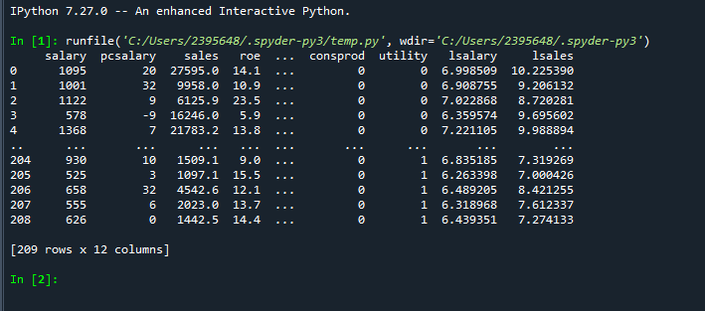

If we proceed to calculate the measure of central tendencies from this dataset based on the salary of the CEOs and the then attempt to group these salaries by Finance and industry variables, we get the following output:

mean1 = df['salary'].mean()

sum1 = df['salary'].sum()

max1 = df['salary'].max()

min1 = df['salary'].min()

count1 = df['salary'].count()

median1 = df['salary'].median()

std1 = df['salary'].std()

var1 = df['salary'].var()

# Second group

groupby_sum1 = df.groupby(['finance']).sum()

groupby_count1 = df.groupby(['finance']).count()

# Second group

groupby_sum1 = df.groupby(['indus']).sum()

groupby_count1 = df.groupby(['indus']).count()

# Output group one

print ('Mean salary: ' + str(mean1))

print ('Sum of salary ' + str(sum1))

print ('Max salary: ' + str(max1))

print ('Min salary: ' + str(min1))

print ('Count of salary: ' + str(count1))

print ('Median salary: ' + str(median1))

print ('Std of salary: ' + str(std1))

print ('Var of salary: ' + str(var1))

# Output group two

print ('Sum of values, grouped by the finance: ' + str(groupby_sum1))

print ('Count of values, grouped by the finance: ' + str(groupby_count1))

# Output group three

print ('Sum of values, grouped by the indus: ' + str(groupby_sum1))

print ('Count of values, grouped by the indus: ' + str(groupby_count1))

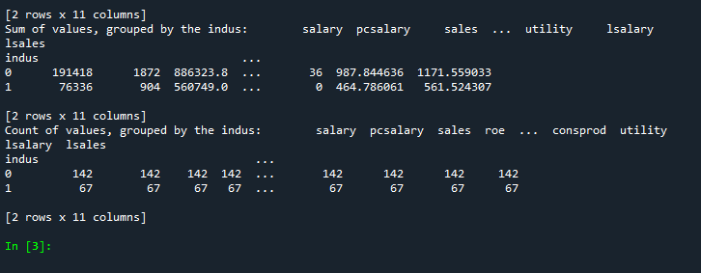

**Regression analysis**

Based on the dataset provided above, a regsrsional analysi was done against the salary and the roe of the companies as below;

#Regression analysis

import pandas as pd

#import numpy as np

import matplotlib.pyplot as plt

#import statsmodel.api as sm

df = pd.read_csv (r'salroe.csv')

print(df)

y = df['salary']

x = df['roe']

plt.scatter(x,y)

plt.xlabel('roe',fontsize = '20')

plt.ylabel('salary', fontsize = '20')

plt.show()

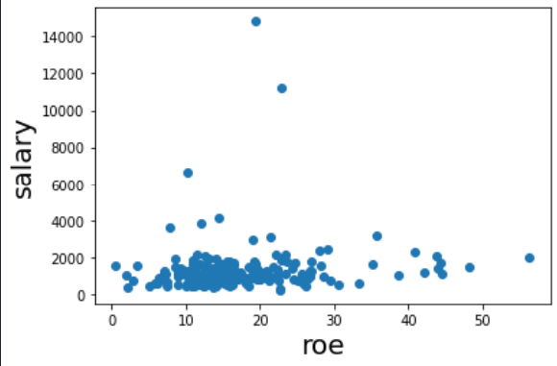

**Observation from the dataset**

From the results obtained, each data point in the graph presents a CEO salary, if randomly selected, it can be seen that as the ROE increases, neither does the salary, actually, there is no relationship between the roe on investment sand the CEO salary, as the ROE increases, the salary is not affected in any way.

**Observations:**

-There were more males than females as CEOs in most companies

-Males earned a higher salary than their counterparts

A simple plot of the salary incomes of some of the staff and their education levels is as shown below;

import pandas as pd

df = pd.read_csv (r'education.csv')

df.plot(x = 'salary in dollars', y='education', kind = 'scatter')

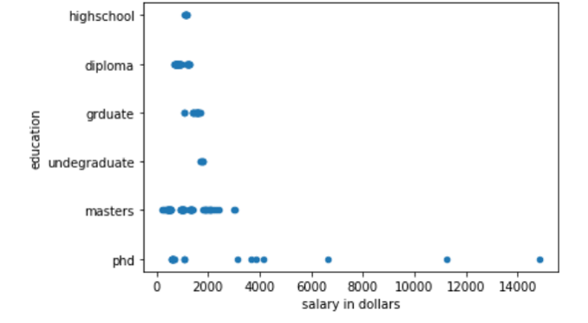

**Observations:**

-There are more CEOs with a master’s degree earning between 1.5K to 3.5K in salaries per month

-Very few PhD holders are earning above 10k in monthly salaries

**Variable significance**

import pandas as pd

import numpy as np

from sklearn import datasets, linear_model

from sklearn.linear_model import LinearRegression

import statsmodels.api as sm

from scipy import stats

data = pd.read_csv (r'salroe.csv')

X = data.salary

y =data.roe

X2 = sm.add_constant(X)

est = sm.OLS(y, X2)

est2 = est.fit()

print(est2.summary())

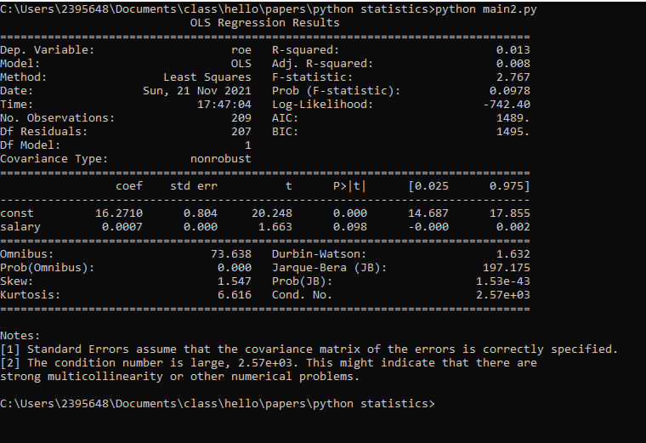

Another analyses of salary against gender produced the following:

import pandas as pd

df = pd.read_csv (r'gender.csv')

print(df)

df.plot(x = 'salary in dollars', y='gender', kind = 'bar')

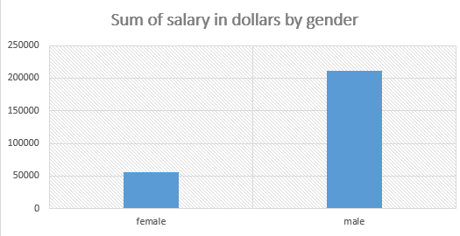

**Measuring covariance relationships**

Given the measurable variable attributes of salary and company return on investments, from the dataset, a covariance relationship was established as follows:

import pandas as pd

import matplotlib.pyplot as plt

df = pd.read_csv (r'Roi.csv')

print(df)

plt.scatter(df['ROI'], df['salary in dollars'])

plt.xlabel('ROI')

plt.ylabel('salary in dollars')

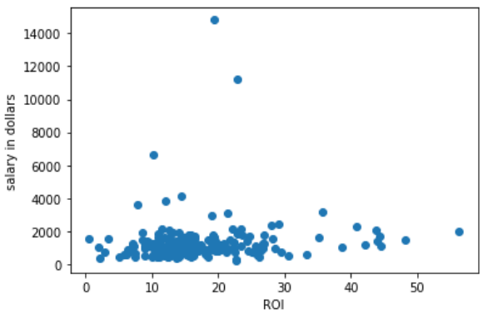

**Observation:**

The analyses revealed that there was no direct relationship between a company’s return on investments and the amount of salary that the CEOs earned, the distribution between high, medium and low ROI was random and scattered, making no meaningful statistical observations, contrary towards would be expected that campiness that have higher ROI have also exhibit higher salaries among top management and vice versa.

**Conclusions and recommendations for future research**

From the study conducted, it can be consulted that organisations pay their CEOs depending on a number of factors such as age, experience, ROI, education and gender. That there are more male CEOs than females. Graduate education could earn one a job as a CEO and that there is no direct relationship between a company’s return on investment and the amount of salary to pay their CEOs. Future researchers could take this study higher by trying to establish the external organisational factors that affect chief officer salaries in organisations.

**REFERENCES**

Chaudhry, Muhammad Shahzad, et al. "Exploring the relationship between salary satisfaction and job satisfaction: A comparison of public and private sector organizations." *The Journal of Commerce* 3.4 (2011): 1.

Andersen, Lotte Bøgh, et al. "Attracting public service motivated employees: How to design compensation packages." *International Review of Administrative Sciences* 78.4 (2012): 615-641.

Henderson, Andrew D., and James W. Fredrickson. "Top management team coordination needs and the CEO pay gap: A competitive test of economic and behavioral views." *Academy of Management Journal* 44.1 (2001): 96-117.

D’Ambrosio, Conchita, Markus Jäntti, and Anthony Lepinteur. "Money and happiness: Income, wealth and subjective well-being." *Social Indicators Research* 148.1 (2020): 47-66.

Singh, Sanjay Kumar, et al. "Top management knowledge value, knowledge sharing practices, open innovation and organizational performance." *Journal of Business Research* (2019).

Data collection:

Is the initial step in the decision-making process. Top management relies on decision support tools to develop ready-to-use algorithms and tools that will necessitate the process of highlighting critical decisions to be made in various approaches to resolving company difficulties. Data points are another term for the sources of these data. Data points are critical entry points for data into storage devices.

Typically, the organization has servers within the apps on its network that are intended for information consumption and full use. These are some examples of data points. Customer relationship management systems, firm mobile apps, internet portals, points of sale, contact forms and links, call logs, email dialogues, and social media answers are all examples of customer relationship management systems. What happens if a corporation receives an excessive amount of data that it cannot handle? This is where big data comes in. The following questions will be addressed by big data;

1. What kind of information is this?

2. From where is it coming?

3. Who is submitting it?

4. Where should we keep it?

5. How will we examine it?

Big data has several characteristics, like being quick moving, enormous in volume, and containing a greater quantity of truth. The data storage is the next phase in the data processing. Also, various types of online data storage exist and leave data traces along the way. When you go shopping and swipe your card over the POS, card reader, or other machine, traces of your personal information are left all over the place.

Alternatively, when we go online to search for a specific product to buy, the Google search engine automatically and secretly monitors our key words, maps them to our locations, and then sends us recommendations from other sites based on the type of item and the desire to buy it, as well as how closely it is related to the items we are actually looking for online.

This is one of the reasons why, after looking for a product on, you may receive numerous recommendations from other websites, mobile apps, and social media pages. This type of targeted selling may appear to be illegal and uncalled for, although it is permissible in other ways. Perhaps we should revisit the laws and procedures in place to preserve the privacy of human data; such privileges should not be secured just by obscure terms and conditions that most consumers do not read or comprehend. When it comes to data storage, we can see that programs use three main sorts of formats to store data.

> Structured

> Unstructured

> No storage (web 3.0)

Structured database systems are traditional database systems that store data in the, metadata, and table information and then join different tables together, as we will see later in this discussion.

In contrast, a database management system (DBMS) is a tool for managing structured data.

MySQL, Oracle, DB2, and Postgres are examples of DBMS.

Almost all of these databases operate in the same way; the differences may be minor syntax agreements here and there, the company name and the weather, or whether or not to accept capital SQL queries or simply ignore them. Postgress only accepts lower case queries. Any other query written in upper case will be converted to lower case automatically.

Consider the below table sample for organized /structured database system

Student_id

name

wing

grade

0003

Alex maercies

Blue

4

773

Jontahan Mario

Red

3

6443

Simon Trucey

Green

1

5243

Lucia Degraada

Yellow

2

1109

Kimberly Golden

Purple

3

Structured database systems have been used for a long time and are the oldest in history due to their wide range of applications.

It is the case of legacy systems and databases.

Their applications range from financial systems to healthcare education systems, research and development studies, and financial stocks, among other developer environments.

Unstructured database systems, on the other hand, are the polar opposite of structured databases. Instead of data being stored in organized rows and columns, the data is tied in some unstructured format, making it impossible to tell which particular row or index value position the data is in.

Unstructured data is the industry's second most recent type of database system.

Even some developers and software engineers are unfamiliar with databases.

Unfortunately, this is where most applicators generating large amounts of data will shift their attention and focus, which is ideal because UDBS is the only way current applications connect with big data.

Because UBD does not consider any unique rows and columns, the UDBS will store images, audio, characters, integers, and even documents that can only be accessed as an array.

Consider the following example of an array calling the object:

for (i in siteInfo .users)

{

for (j in siteInfo.users[i])

{

x = siteInfo.users[i][j];

console.log(x);

}

}

The unstructured database array above retrieves an object called site info and returns the associated array of items within the object. This is how a database like this works.

Google's Firebase is one of its products. This is a tool that grants developers and organizations access to a wide range of features, including Firebase data tools. This type of database does not store data in rows or columns. MongoDB is another type of database that is widely used for the same reasons as Firebase. Furthermore, the web 3.0 is the most recent introduction to data storage that is not even stored. You see, when the internet was invented, it all started with static sites, then moved on to dynamic systems, then to smart systems, and now the entire system is almost back to web 1,0, but in a smart and silent way.

Later on, developers would take advantage of the engineers' missed opportunity and leverage on the needs of getting calculations and arithmetic applications on their dataset.

This is where statistical languages like R came into play. R has been a powerful child in attempting to gather quick summary statistics on the concerned measures of central tendencies, summaries on the values of comparison, and also by assisting in providing the necessary forecasting and data descriptive features and values of such datasets.

Furthermore, the language includes an inbuilt mode that allows the researcher to quickly obtain whatever kind of insights they require from such dataset. Among the models used in this language are:

> Linear regressions

> Logistic regressions

> ARIMA models

> KNN model

> Random forest and decision trees

By forecasting the models through a fit function, the models have been effective in attempting to assist scientists in discovering relationships between datasets while also being able to predict the future outcomes of such inputs. Python, despite being old and powerful, has been used to wrangle data throughout the entire data cleaning process, analysis, and even building models to predict the dataset. This application's data analysis and features include the ability to gather data from the internet using custom tools such as beautiful soup. Once his data collection and preparation is complete, Python's built-in libraries such as Numpy, SciePy, and pandas have been used as tools to aid in the data visualization process.

Nonetheless, an old but still widely used approach to data analysis is a tool that we are all familiar with: Microsoft Excel. This tool benefits almost every user and basic analyst, regardless of experience or age. Using Microsoft Office, as we will see in the following chapters, an individual can quickly clean their dataset, obtain measures of central tendencies, and then apply the relevant required functions on the data analyses tool pack to quickly obtain meaningful information from the dataset, as we will discuss in the final section of this research paper in the analyses section.

Software as a service (SAS) refers to web tools that are specifically designed to assist users in quickly navigating their analysis. With particular emphasis on the analyses of the products and outputs derived from the dataset that they intend to use. Furthermore, in this study, the SAS tools will form the foundation of our analysis, with key objectives and instructions sent on how to use the SAS software to convert a CSV dataset of our choice into the correct.bat file that we can use on our application to make meaningful and useful data derivations from.

We'll be able to quickly get the right analysis for this work by clicking and dragging.

All of this is necessary to assist the company in understanding and measuring the requirements of developing an effective business information system, with a particular focus on datasets, systems, and whether to consume a structured or unstructured database, the method and language of analysis, and the type of models to apply for each dataset.

Finally, the SAS online tool and the previously mentioned SQL language will be considered here for the development and management of the BI application to help management understand the features and capabilities of BI applications.